NOTICE OF PUBLIC HEARING
AND JOINT REVIEW BOARD MEETING
REGARDING THE PROPOSED CREATION OF
TAX INCREMENTAL DISTRICT (TID) NO. 5
VILLAGE OF CALEDONIA, WISCONSIN

Notice is Hereby Given that the Village of Caledonia will hold an organizational Joint Review Board meeting on April 15, 2019 at 11:00 a.m., at the Caledonia Village Hall, located at 5043 Chester Lane.

The purpose of the meeting is to organize a Joint Review Board for Purposes of considering the proposed creation of, and the proposed project plan for, Tax Incremental District No. 5 (the “District”).

Notice is Hereby Given that the Plan Commission of the Village of Caledonia will hold a public hearing on April 15, 2019 at 5:00 p.m., at the Caledonia Village Hall, located at 5043 Chester Lane, for the purpose of providing the community with a reasonable opportunity to comment upon the proposed creation of the Project Plan for the District.

The proposed boundaries of the District would be within an area generally detailed on the map below.

The District is expected to be a rehabilitation-conservation district based on the identification and classification of the property proposed to be included within the District.

Proposed project costs include various public improvements and cash grants to owners or lessee or developers of land located within the District (development incentives), professional and organizational services, administrative costs, and finance costs. The proposed costs include projects within the proposed boundary and within a ½ mile radius of the proposed boundary of the District.

All interested parties will be given a reasonable opportunity to express their views on the proposed creation of the District, the proposed boundaries of the District, and the proposed Project Plan thereof. A copy of the Project Plan, including a description of the proposed boundaries, will be available for viewing in the offices of the Village Clerk at the Caledonia Village Hall, located at 5043 Chester Lane during normal business hours and will be provided upon request.

Such hearing shall be public and citizens and interested parties shall then be heard. This hearing may be adjourned from time to time.

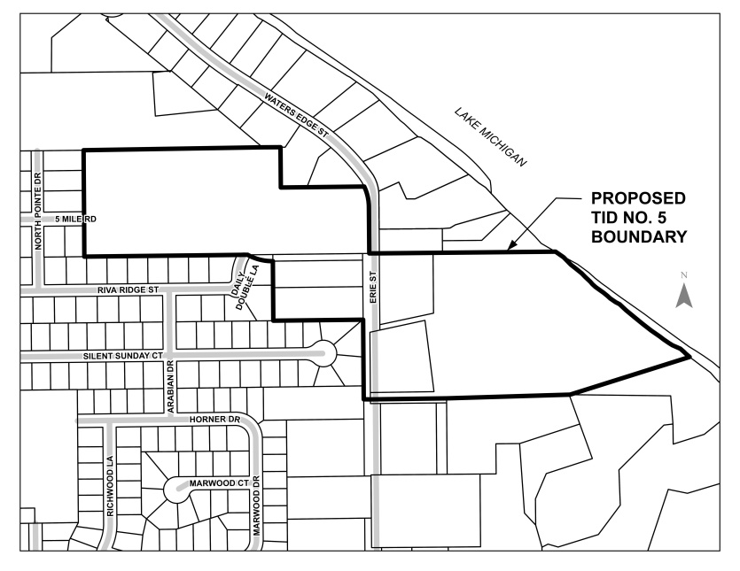
By Order of the
Village of Caledonia, Wisconsin

Published
April 1, 2019
April 8, 2019

